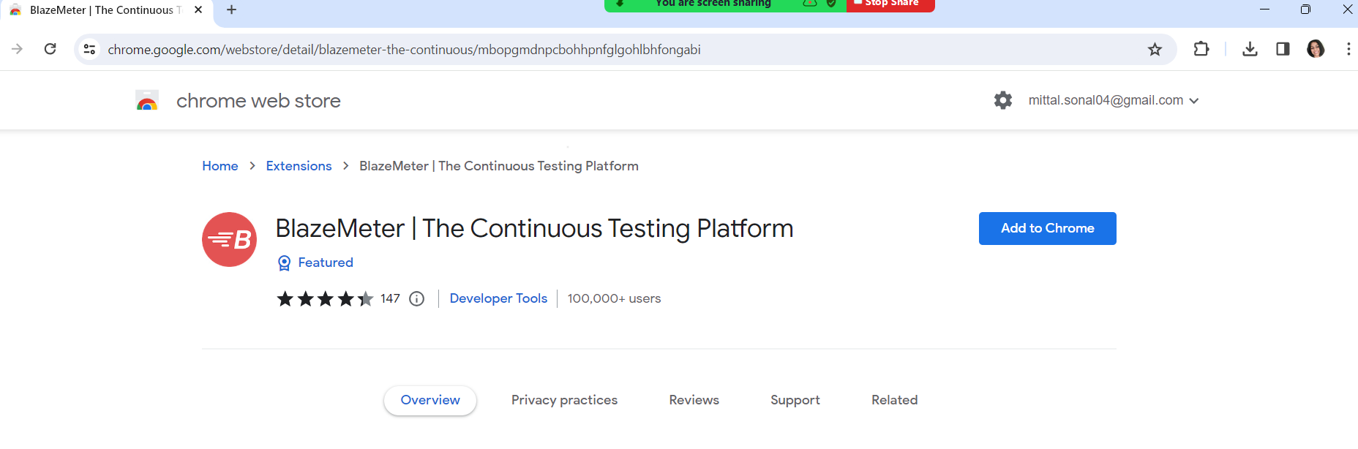

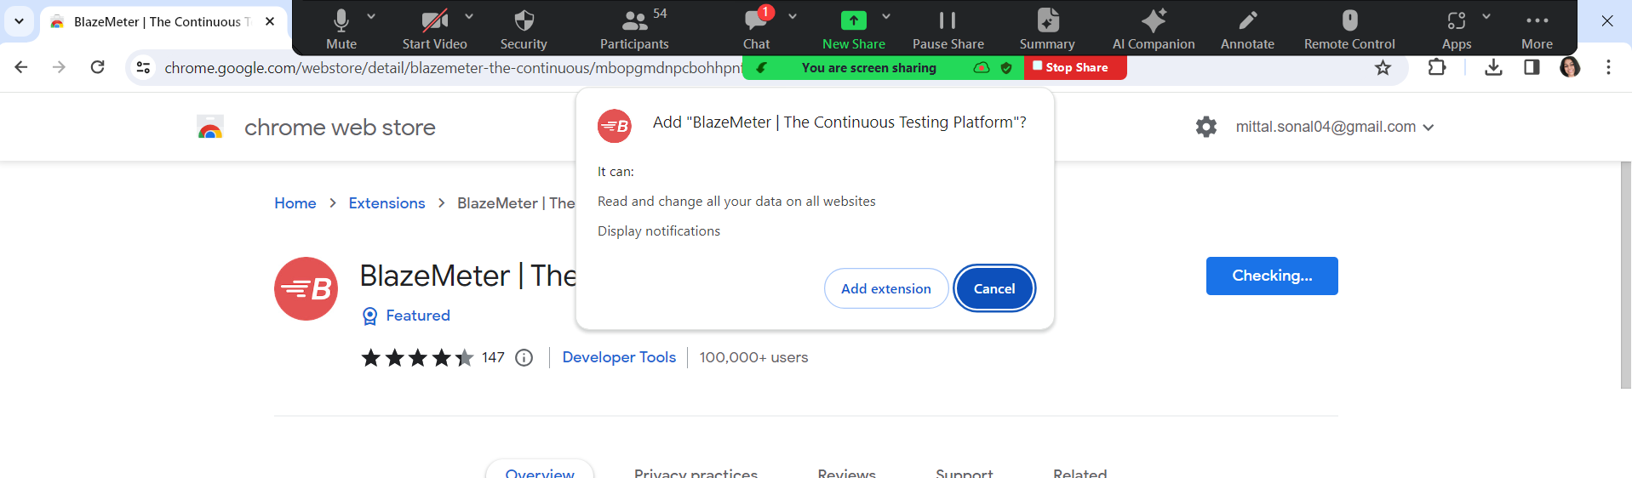

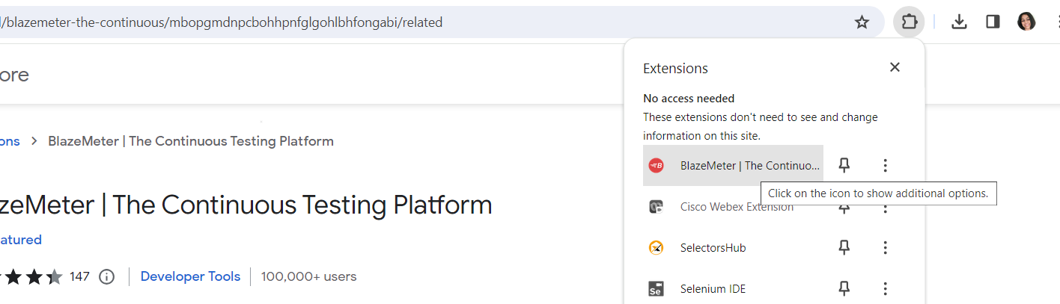

Click on Signup

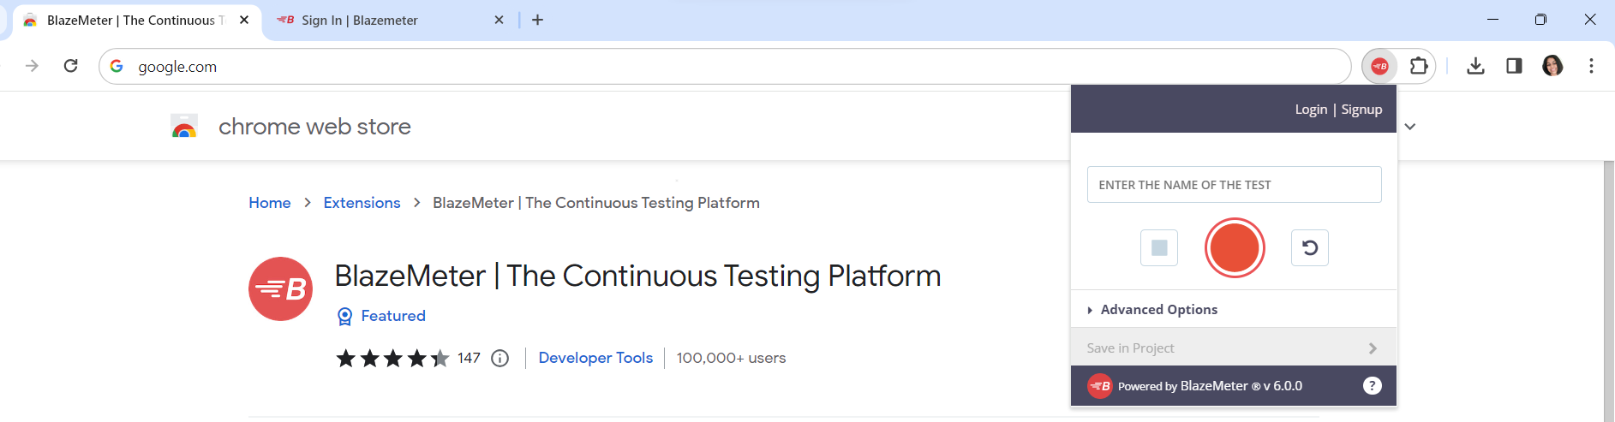

Always loginto blazemeter before recording script

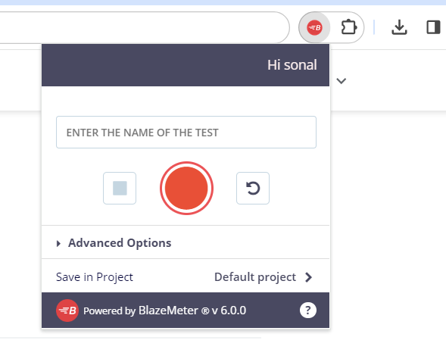

Click on red button to start recording

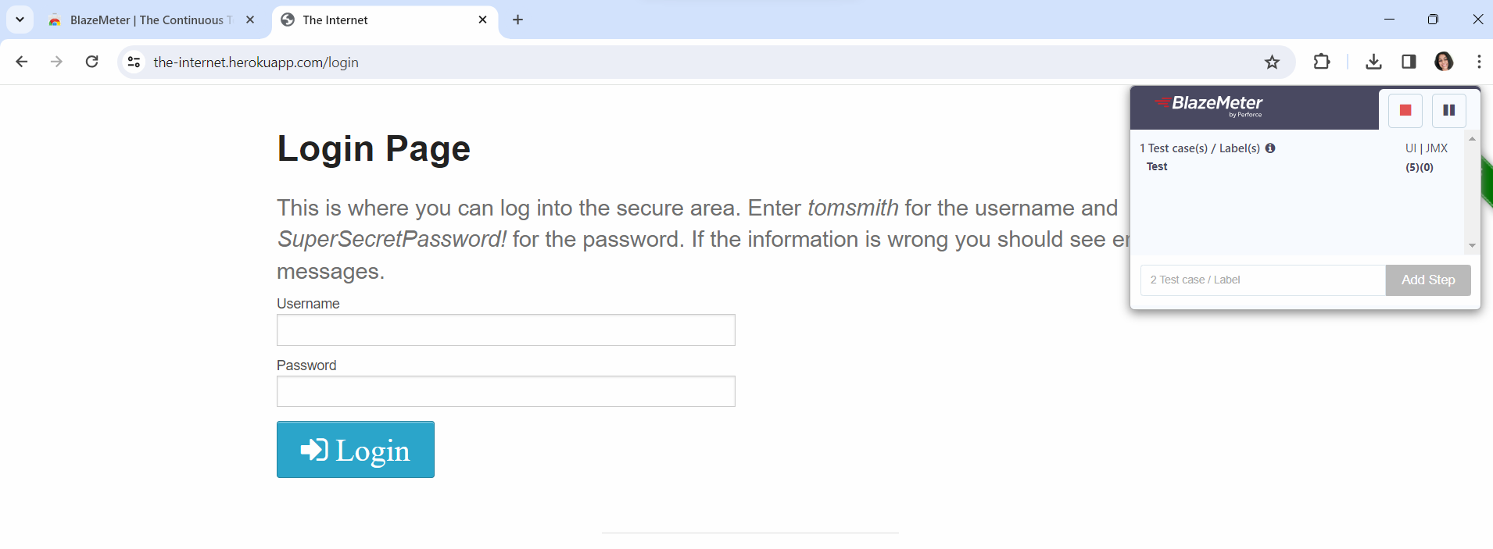

Click on red button to stop recording

To get the recording 🡪 again open the blazemeter extensison 🡪 save button🡪 click 🡪 save as JMX file

The file will be downloaded in your downloads folder

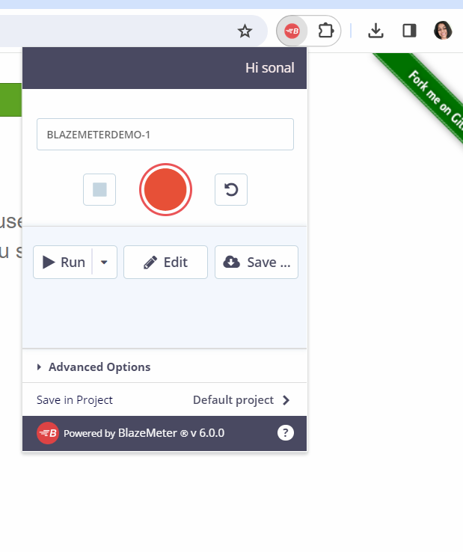

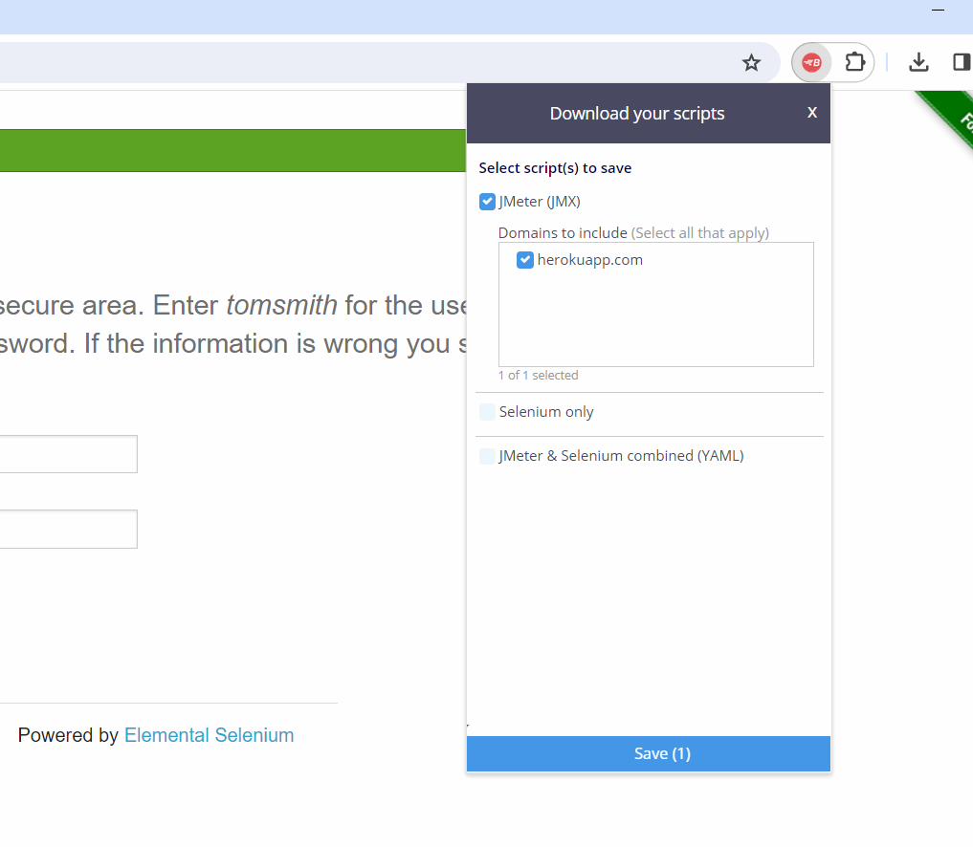

Script will be in downloads folder

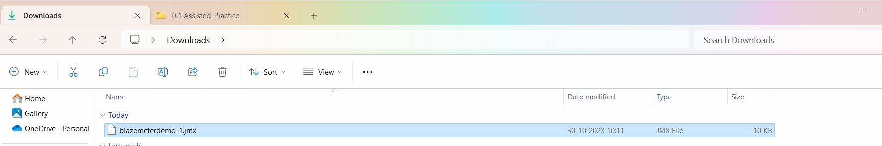

Now open the script in Jmeter

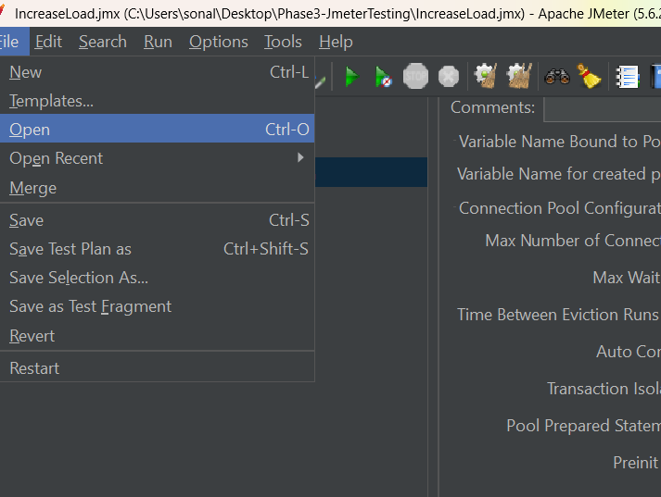

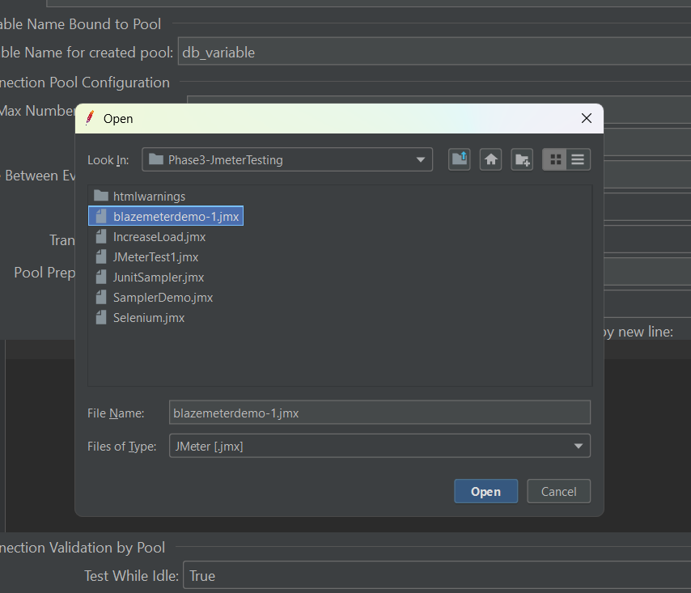

You can move the scripts in Simple controllers and apply naming policy

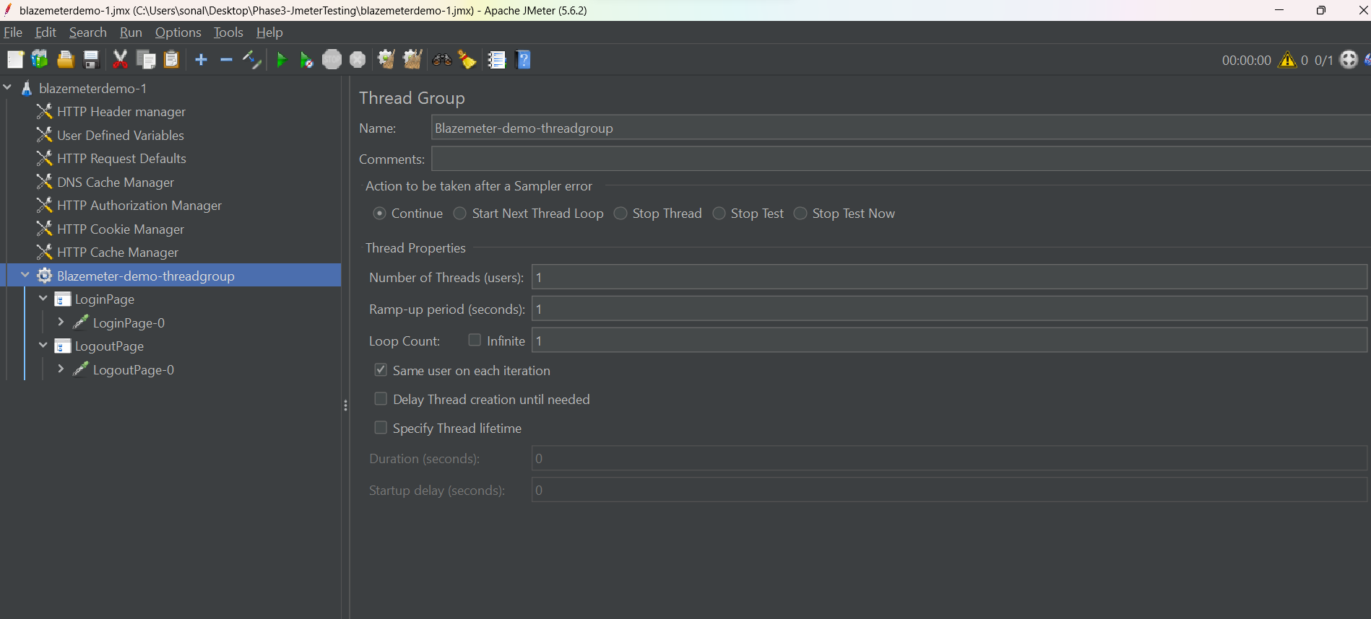

Switch Controller:

First go to login page, eneter username and password

https://the-internet.herokuapp.com/login

Go to below link,

https://the-internet.herokuapp.com/

Click on first link

Go to below link,

https://the-internet.herokuapp.com/

Click on second link

Go to below link,

https://the-internet.herokuapp.com/

Click on third link

Go to this page and click on logout button

<https://the-internet.herokuapp.com/login>

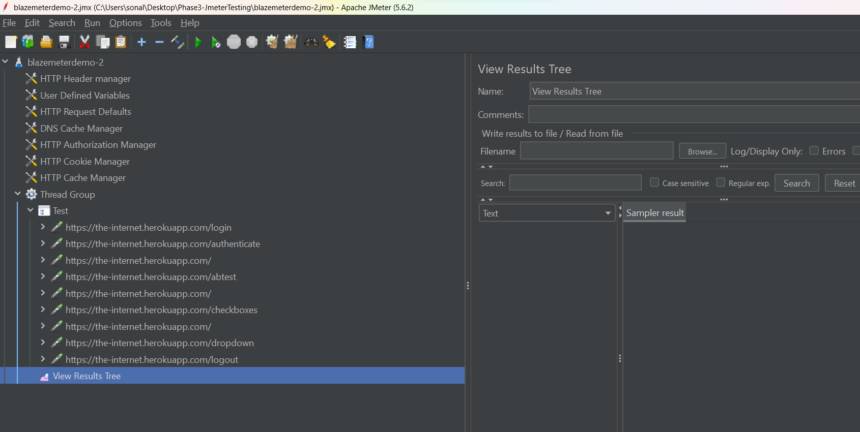

Place your samplers in Simple and Switch controller

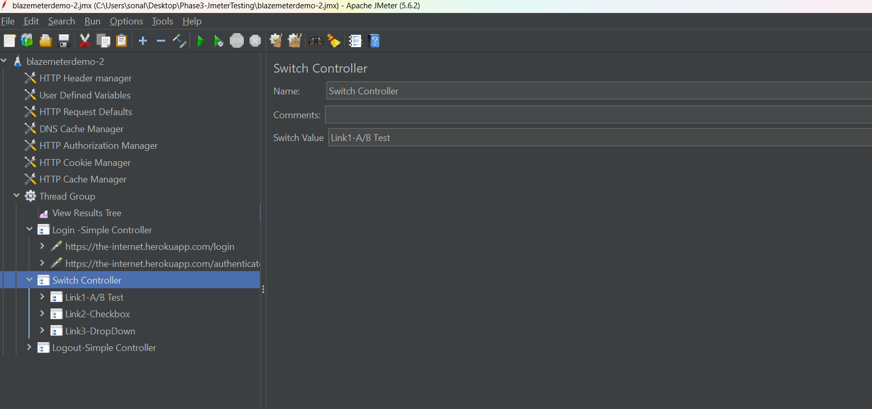

Give Switch value as one of the sampler.

Login 🡪 sample link1-A/btets will run 🡪 logout will run

Interleave Controller:

Precondition -> test1, test2, test3 🡪 post condition

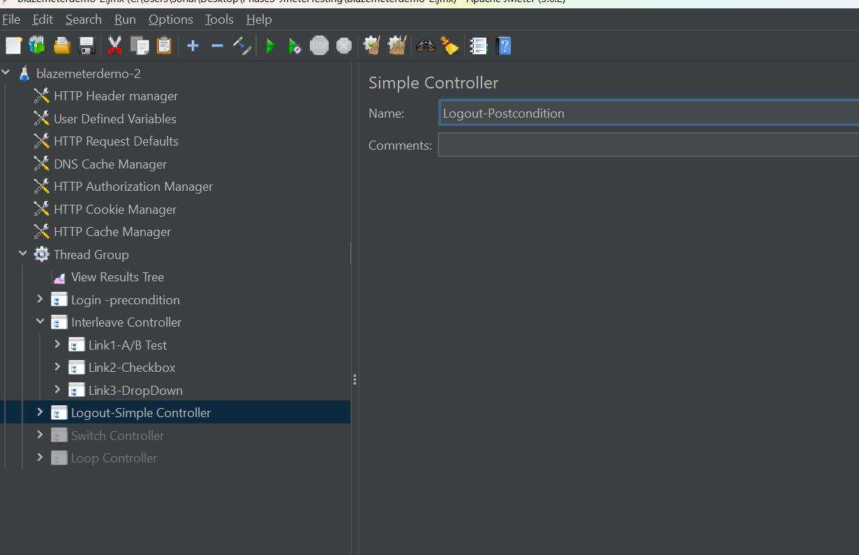

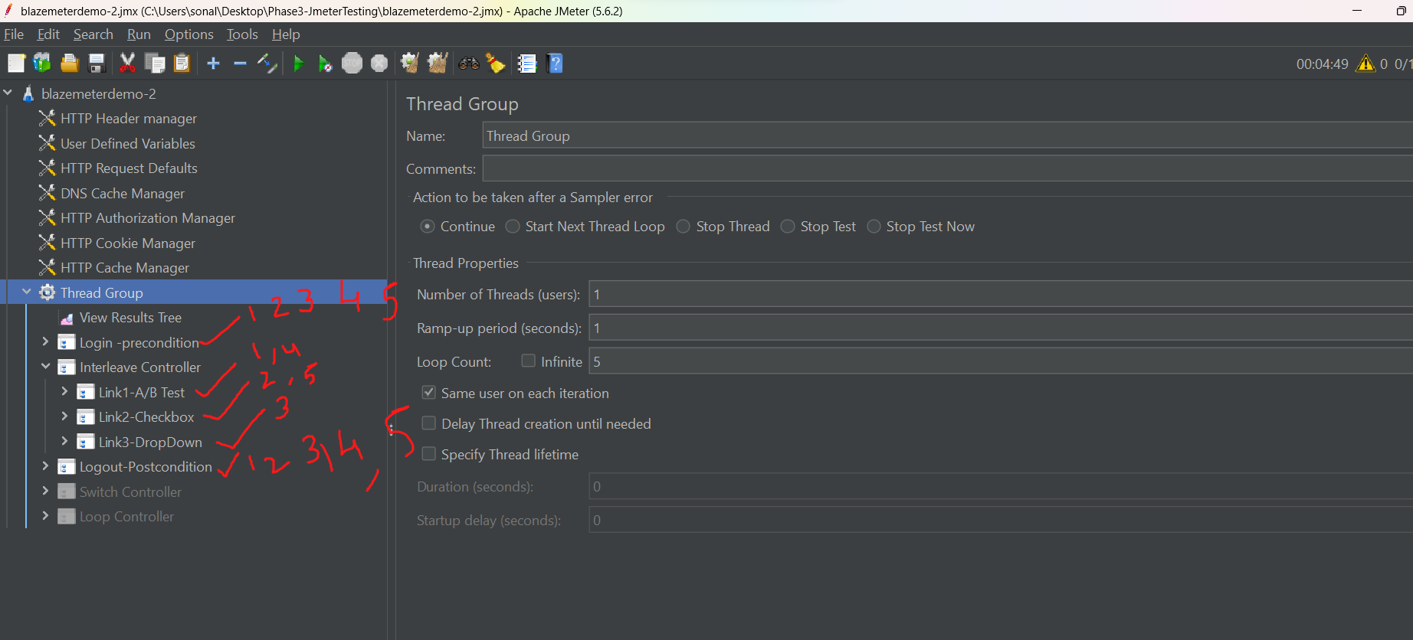

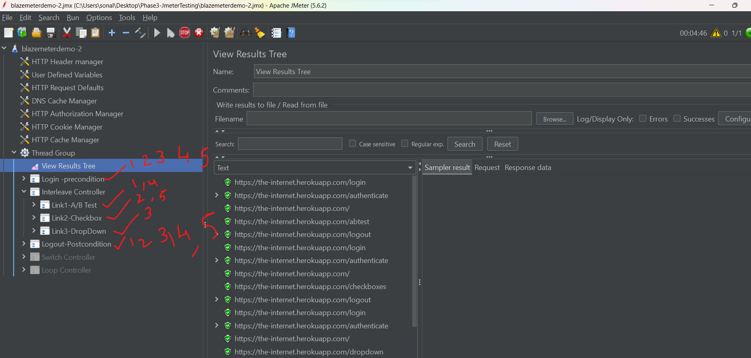

Random Controller : loop count = 3

====================

pre-condition -login -> test3 -> postcondition - login

pre-condition -login -> test1 -> postcondition - login

pre-condition -login -> test2 -> postcondition - login

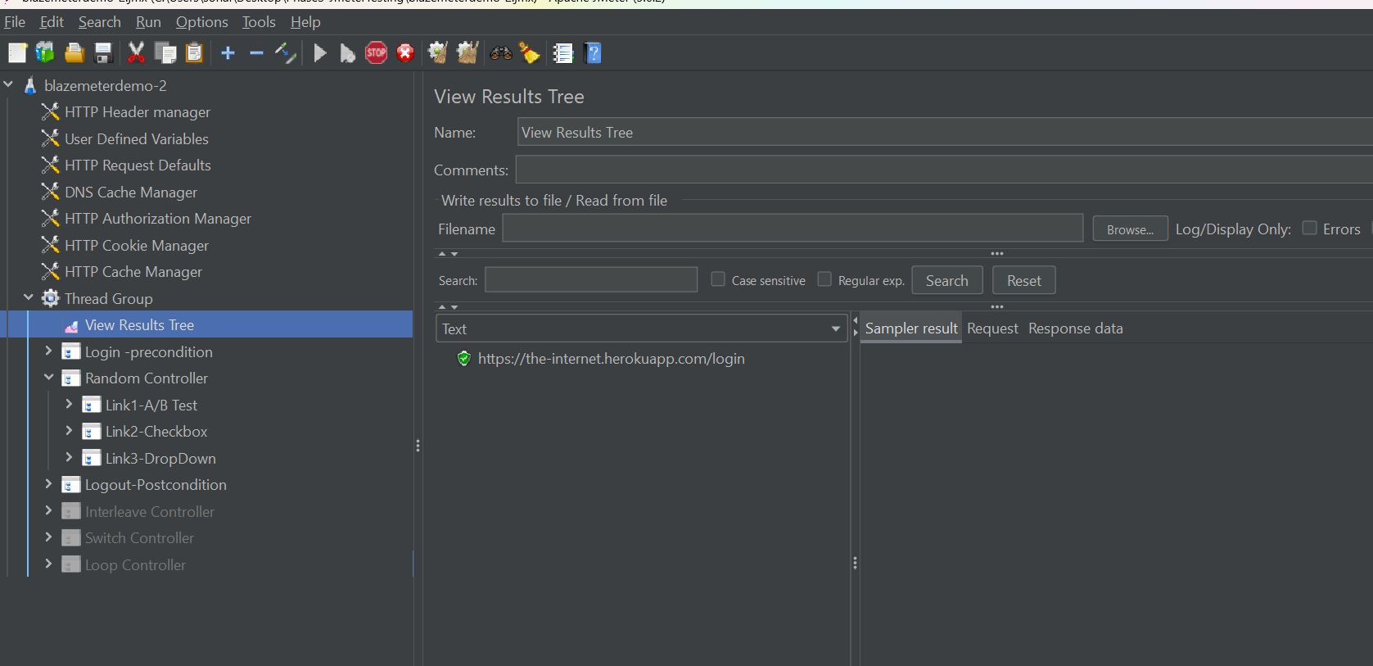

Random order controller:

================================

pre-condition -login -> test3, tes1, test2 -> postcondition - login

pre-condition -login -> test1, tes3, test2 -> postcondition - login

pre-condition -login -> test3, tes2, test1 -> postcondition - login

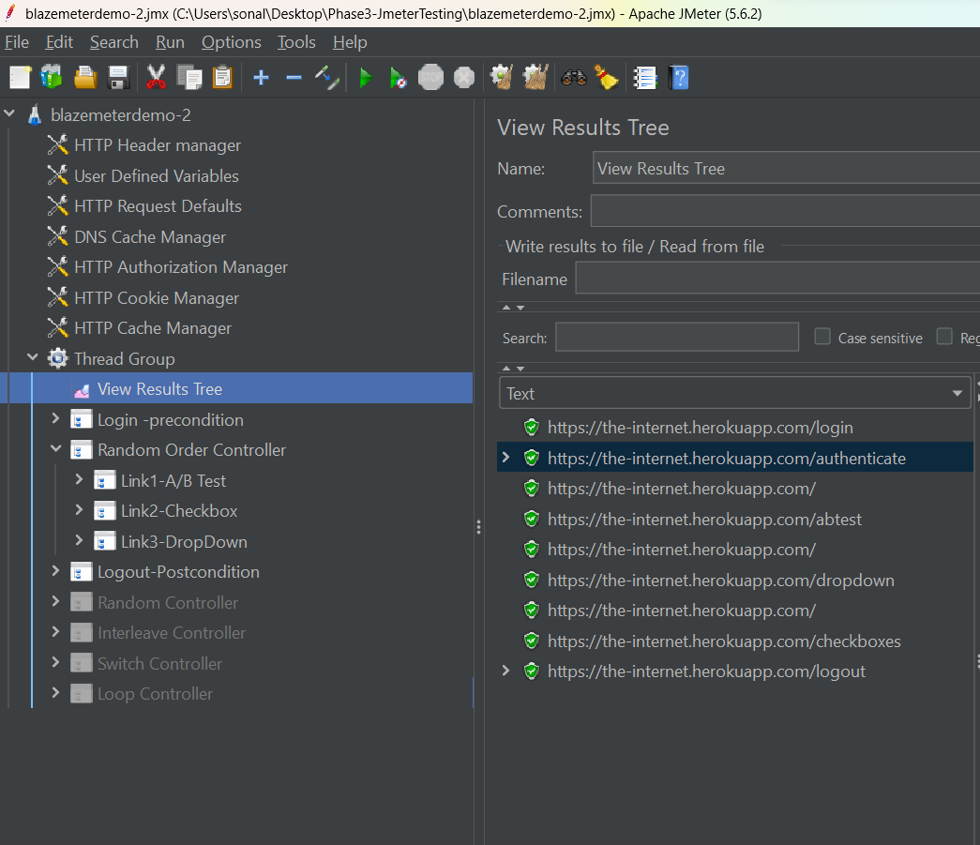

Assiteted practice:

For each controller – regular expression

Pre and post processors

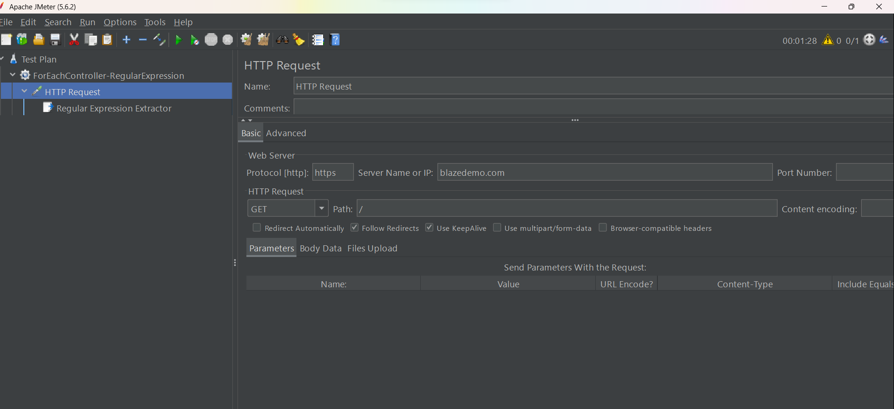

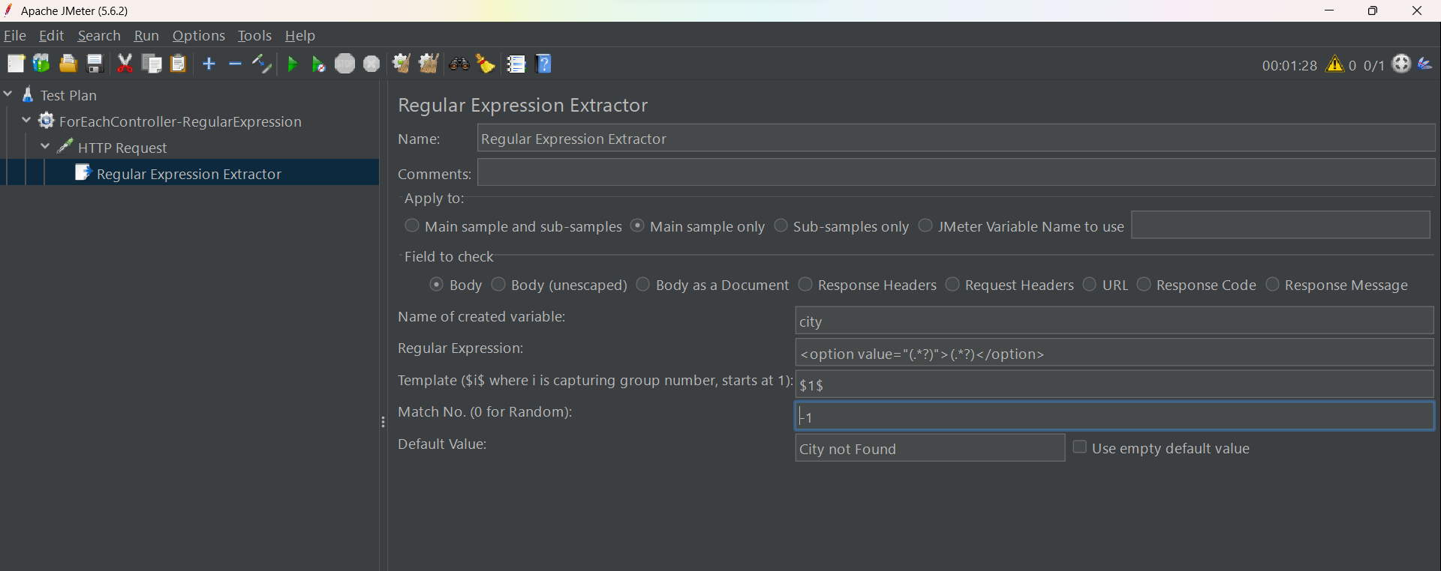

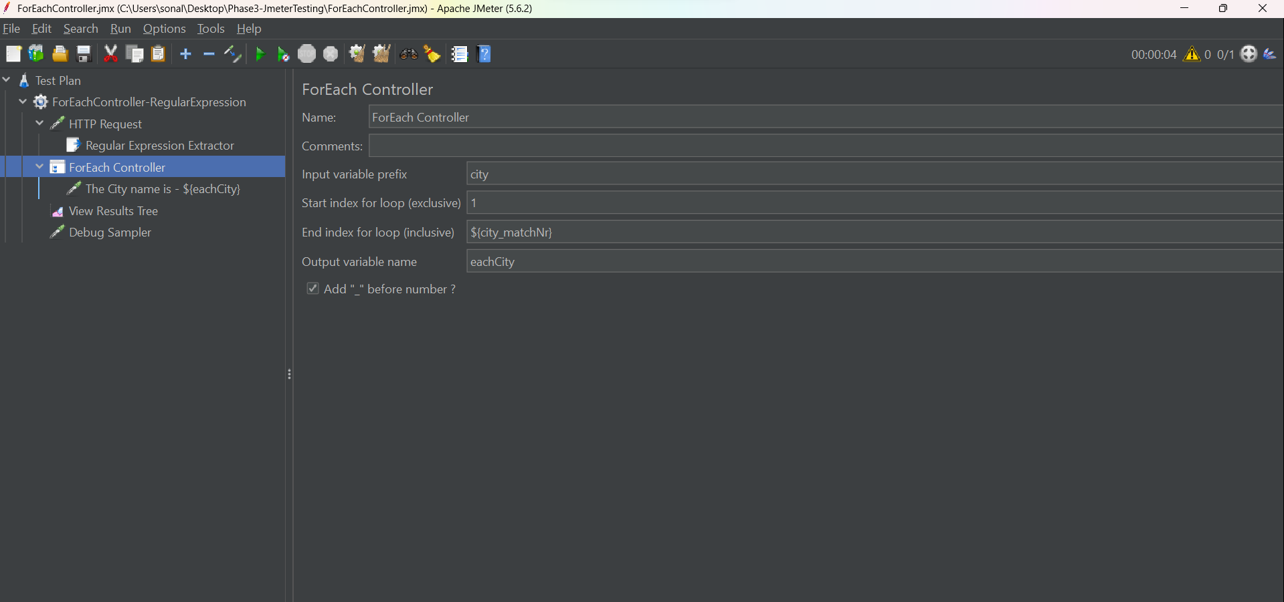

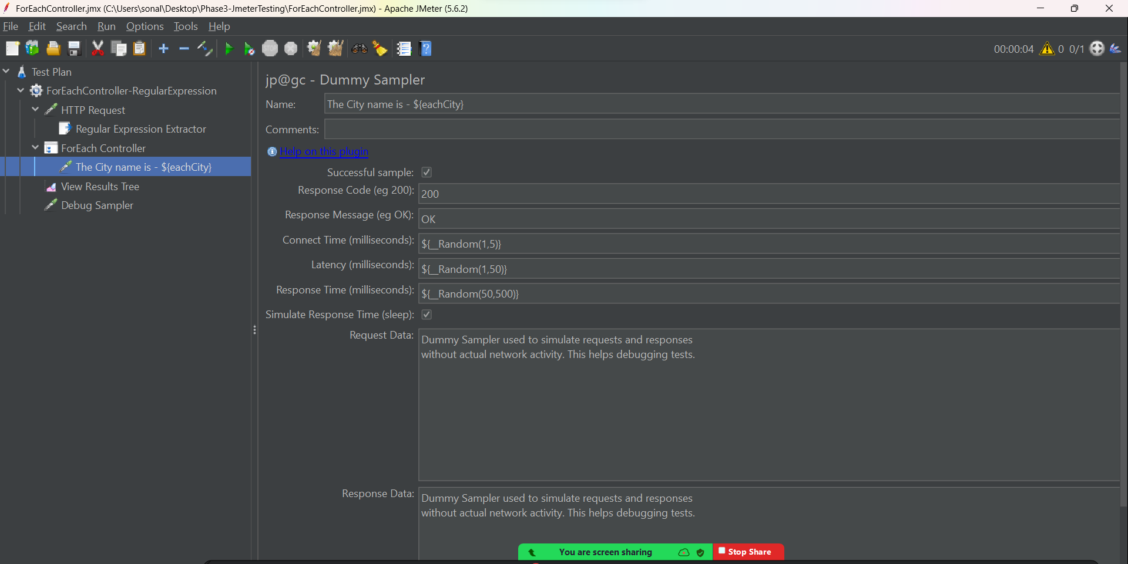

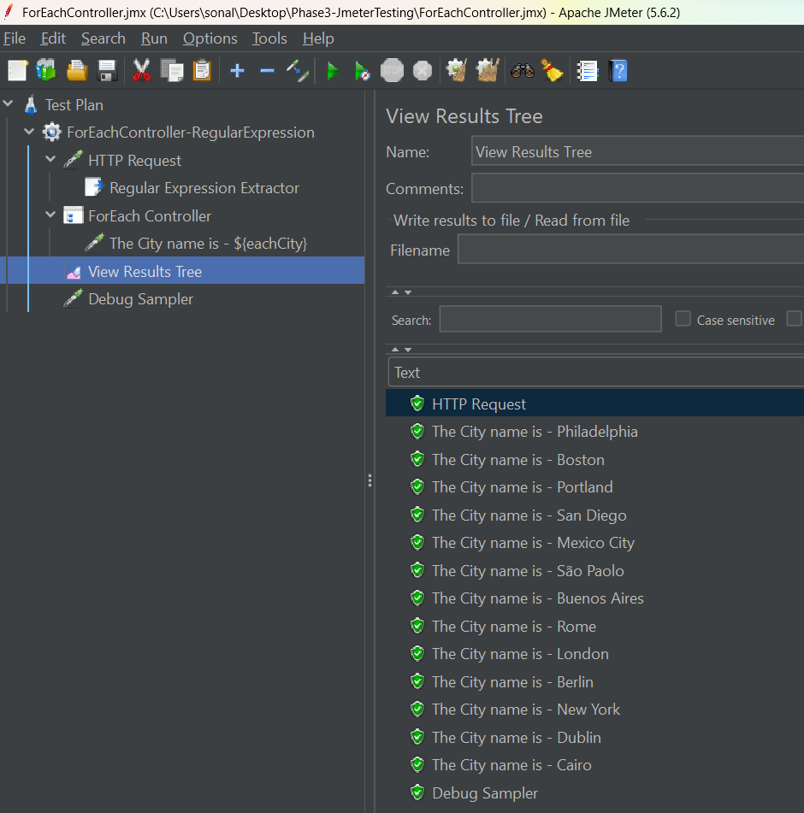

For each controller – Xpath extractor

